<https://www.udemy.com/course/microservices-with-node-js-and-react/learn/lecture/19119926#questions>

we now have all the 4 routes put together, we are going to look at current-user.ts middleware and extract some logic into two separate middleware.

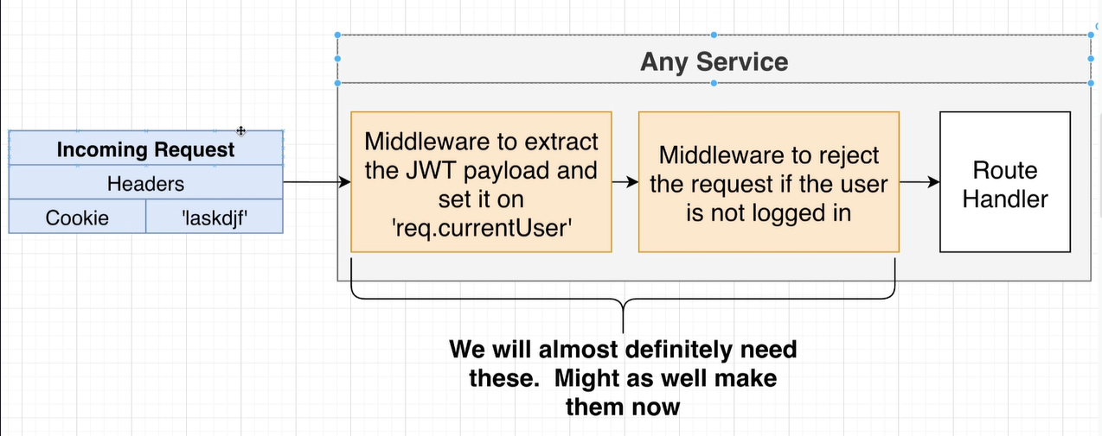

Req.currentUser={}// we cannot just assing a property to req

<https://www.udemy.com/course/microservices-with-node-js-and-react/learn/lecture/19119930#questions>